**Evaluation Only. Created with Aspose.Words. Copyright 2003-2021 Aspose Pty Ltd.**

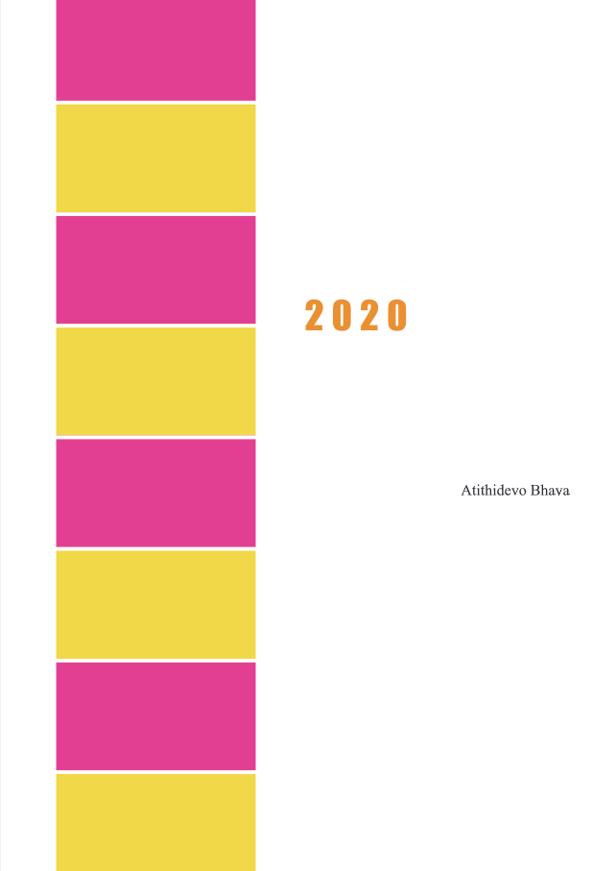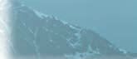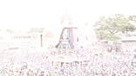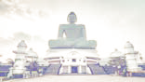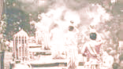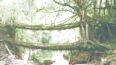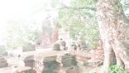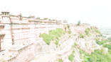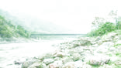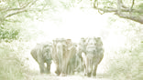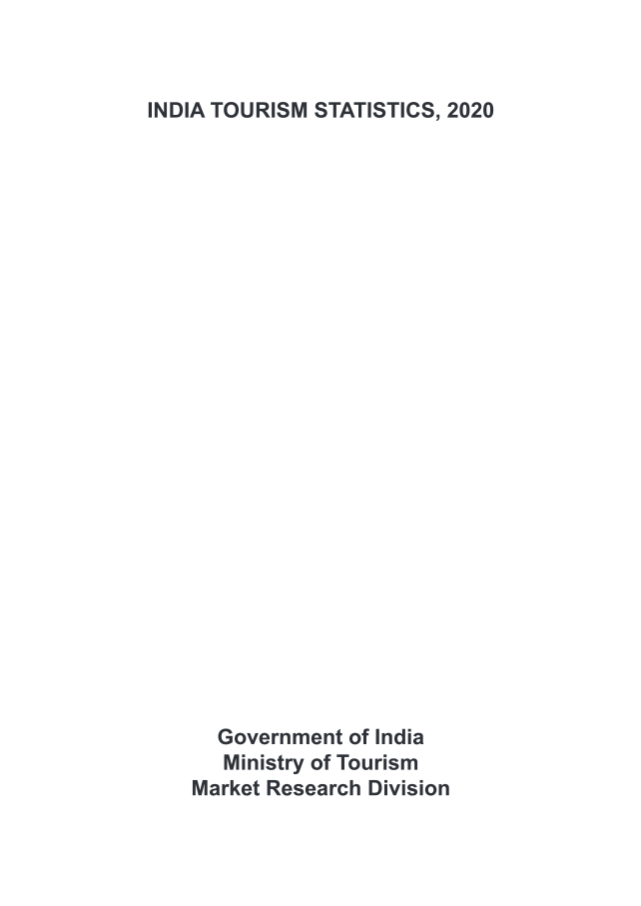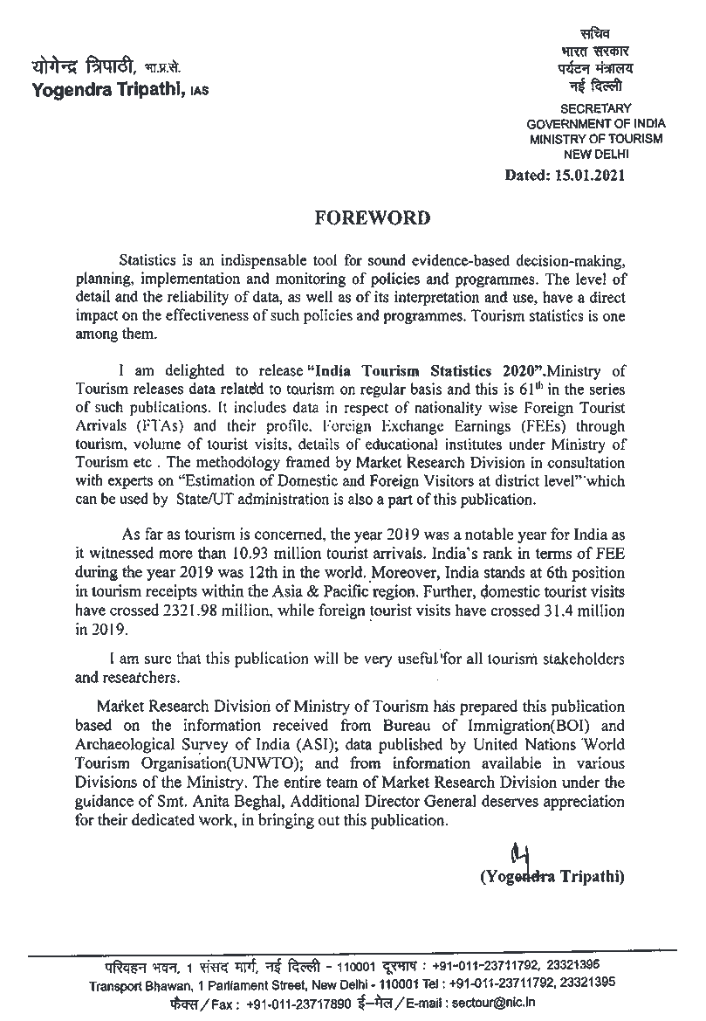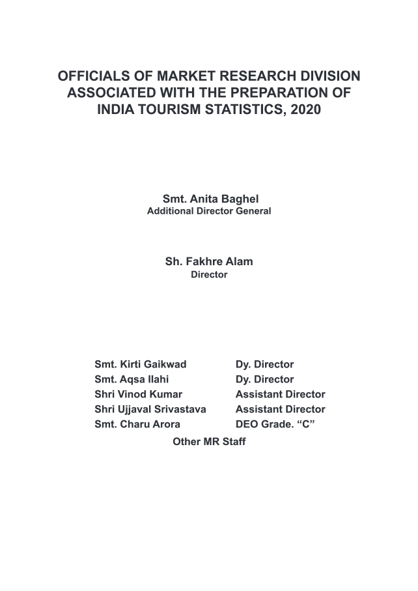

|  |  |  |
| --- | --- | --- |
|  |  |  |
|  |  |  |
|  |  |  |  |  |  |
|  |  |  |  |
|  |  |  |  |  |  |  |  |  |  |  |  |
|  |  |  |  |  |  |  |
|  |  |  |  |  |  |  |  |  |  |
|  |  |  |  |  |  |  |  |  |  |  |  |  |  |
|  |  |  |  |  |  |
|  |  |  |  |  |  |  |  |  |  |  |  |  |
|  |  |  |  |  |  |
|  |  |  |  |  |  |
|  |  |  |  |  |  |  |  |
|  |  |  |  |  |  |  |  |
|  |  |  |  |  |  |  |  |  |  |  |
|  |  |  |  |  |
|  |  |  |  |  |  |  |
|  |  |  |  |  |  |  |  |  |  |  |
|  |  |  |  |  |  |
|  |  |  |  |  |  |  |
|  |  |  |  |  |  |  |  |  |  |  |
|  |  |  |  |  |  |
|  |  |  |  |  |  |  |  |  |  |  |
|  |  |  |  |  |  |  |  |

**This document was truncated here because it was created in the Evaluation Mode.**